Web Design Resit

Table of Contents

Task 1 Research & Design Documentation: 2

Web Server 2

Web Hosting 2

IP Address 3

DNS 4

Internet Services: 4

Task 2 Audience research and design plan. 6

My google form: 6

The User Persona 8

My Lo-Fi wireframes 10

My Style Guide: 13

Hi – Fi Wireframe 14

### Task 1 Research & Design Documentation:

* Glossary of terms:

Web Server- A web server is a software that uses HTTP to respond to users worldwide. The main thing that a web server does is to present content, like images, videos, applications and more. This makes the user store, process and deliver web pages. These are also used in web hosting such as hosting data and web-based applications. A web server usually connects hardware and software together. A web server is connected through the internet and enables data to be exchanged with different devices via the web. Web servers’ controls how a person can access the hosted files. Its software can be accessed through domain names of websites.

A web server comes from other parts of the internet and intranet related software. It’s used for building and publishing websites, web hosting, sending and receiving emails. A web server acts when a request from a browser (such as Google Chrome or Firefox) and a URL of the site is inserted it requests a HTTP file accepts it for the user to be able to view the content and sends it back to the browser.

[Rahul Awati](https://www.techtarget.com/contributor/Rahul-Awati) [, Alexander S. Gillis,](https://www.techtarget.com/contributor/Alexander-S-Gillis) What is a Web Server (online) available at <https://www.techtarget.com/whatis/definition/Web-server> Created on 10-12-2024 accessed on 13-06-2025.

Web Hosting- Web hosting is a cloud service which provides and stores all the files that understands a website on a server and makes it accessible on the internet. Websites are built from files, code, images and more. Web hosts provide the physical and virtual servers that have everything to build and run the website. Web hosting requires a secure and effective functioning website. The way web hosting works is a plan offered by the Internet Service Providers, creates space on a server and can also provide a committed server to hosts a user’s website or web application. Hosting provider presents a dashboard for the user where they can manage their websites and applications. A provider also gives assets like a CPU, RAM, security features, managing emails, etc.

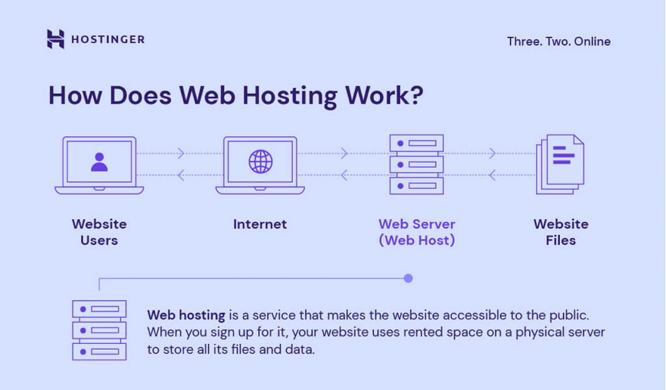

Image 1 - Web Hosting example from website <https://www.hostinger.com/tutorials/what-is-web-hosting>

*A server is the computer hardware and software that stores website files and conveys them to the user.*

IBM What is web hosting? (Online) available at <https://www.ibm.com/think/topics/web-hosting> created on 14-10-21 accessed on 13-06-25

Domantas G What is web hosting- Web hosting explained for beginners (online) available at <https://www.hostinger.com/tutorials/what-is-web-hosting> created on Apr 28, 2025 accessed on 14-06-25

IP Address**-** IP address is short for internet protocol. This identifies numerous devices that are connected to the internet. An IP address means that a number of devices are labelled and assigned to the internet is able to communicate with each other. Computers that communicate via internet share information such as specific locations when using an IP address. There are two distinct versions: the internet protocol version 4 and the internet protocol version 6. The IPv4 is the older version it has enough space for 4 billion IP addresses meanwhile the IPv6 has space for trillions IP addresses. There are different IP addresses such as private, public, static and dynamic. Each device that is connected to the internet has an IP address that allows a smoother transfer of data between two devices permitting units to communicate within each other. An IP address works by helping your device access the internet and to find any type of data or content that’s located into the retrieval. An IP address can identify the host, network and the location of the device.

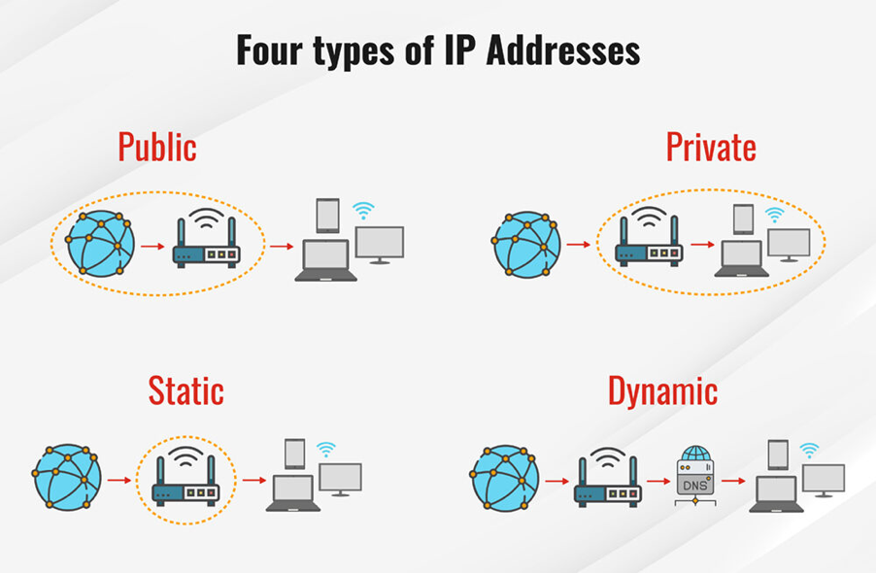

Image 2 - IP addresses - 4 different types example from website <https://www.fortinet.com/resources/cyberglossary/what-is-ip-address>

Fortinet What is an IP address? How does it work? (Online) available at <https://www.fortinet.com/resources/cyberglossary/what-is-ip-address> created on NA accessed on 14-06-25

A domain name is a key part of the Internet infrastructure. This provides a readable address for the user to be able for any web server available. Any computer connected to the internet can be accessed through a public IP address. A domain name is made of several parts and is separated by dots. Each of these parts represents specific data regarding the whole domain. TLD, short for Top Level Domain, serves a purpose behind the domain name. Some popular generic TLDs are (.com, .org, .net). There are also local TLDs, such as (.us, .fr), and others like (.gov), which are used for government websites, and (.edu), which is reserved for educational institutions. The domain name cannot be bought instead, one itself would use a domain name that is not in use anymore.

MDN web docs (online) available at <https://developer.mozilla.org/en-US/docs/Learn_web_development/Howto/Web_mechanics/What_is_a_domain_name> created on NA accessed on 27-06-25

DNS is short for Domain Name System. It is like a phone book for the internet. Users can access data online through domain names. A web browser interacts through an IP address, and the DNS converts domain names to addresses. DNS servers remove the need for users to remember long IP addresses such as 192.168.1.1. The way DNS works involves transforming a hostname example ([www.idk.com](http://www.idk.com)), into a computer IP Address, and it locates the webpage. The Domain Name System is split into two, the Recursive DNS server and Authoritative DNS server.

HTTP and HTTPS are protocols used for communication , but they are both completely different in many ways mainly its security.   
These are both protocols to access a website. HTTP allows the data to be transferred from the client's browser to a web server, which does not encrypt the data, making it at risk of interception. On the other hand, HTTPS adds another layer of extra security. This works by encrypting through SSL/TLS, making data more private and secure during conversion. It is important for a website that has sensitive data, such as login credentials or payment details. Most websites use HTTPS to protect the viewer; this can be indicated by the icon shown in the browser address bar.

SSL/TLS is a digital certificate that secures the connections between the client's browser and the website by securing the information that is transferred between them. SSL (short for Secure Socket Layer) and TLS (short for Transport Layer Security) protect sensitive information such as passwords and credit card numbers from being taken by hackers. The certificate also confirms the website's identity helping viewers to communicate with a site. The encryption allows the use of HTTPS is shown in the form of a lock icon to show the viewer that it is a secure and safe website. Without these the website would be at risk to use for the viewer.

Task 1 no 2:

### Internet Services:

* Identify two Distinct Services :

1. <https://trends.builtwith.com/cdn/CDN-JS> - CDN JS
2. <https://trends.builtwith.com/cdn/Cloudflare-JS>  - Cloudflare JS

### CDN JS

Its Function:

A CDN JS functions like a JavaScript code that is packed through a Content Delivery Network to enhance the website speed and efficiency. These are networks located worldwide that deliver content like JavaScript libraries, from the closest server that is located to the user. When including a JavaScript file from a CDN, developers can use the built-in functions found in libraries such as jQuery or Bootstrap, without hosting the files themselves.

What is the value:

### Cloudflare JS:

Its Function:

Cloudflare CDN is a Content Delivery Network and a Security Service. This works by caching all the of the website's static data and locates it worldwide. When someone visits a website the Cloudflare CDN loads data from the closest server that is in that area example Malta. As mentioned, it is also a security service this provides DDoS protection, SSL encryption, firewall rules, and other security features.

What is the Value?

Cloudflare improves the website's overall performance, security, and reliability. It serves as a middle layer between the website and the user, protecting the website from threats such as hackers, bots, and DDoS attacks. Cloudflare also speeds up the website by keeping content on servers worldwide. This reduces the time it takes for pages to load. Additionally, it gives safe connections through SSL/TLS encryption, making the data safe while being transferred. These features, Cloudflare helps websites to stay secure, quick, and available for users.

One Improvement:

### Task 2 Audience research and design plan.

* Target Audience research.

### My google form:

<https://docs.google.com/forms/d/e/1FAIpQLSeGSa-YQEngWS4SFpQKIUYIMXufA4q60Q_nGJ7UIZDnBkdvyw/viewform?usp=dialog>

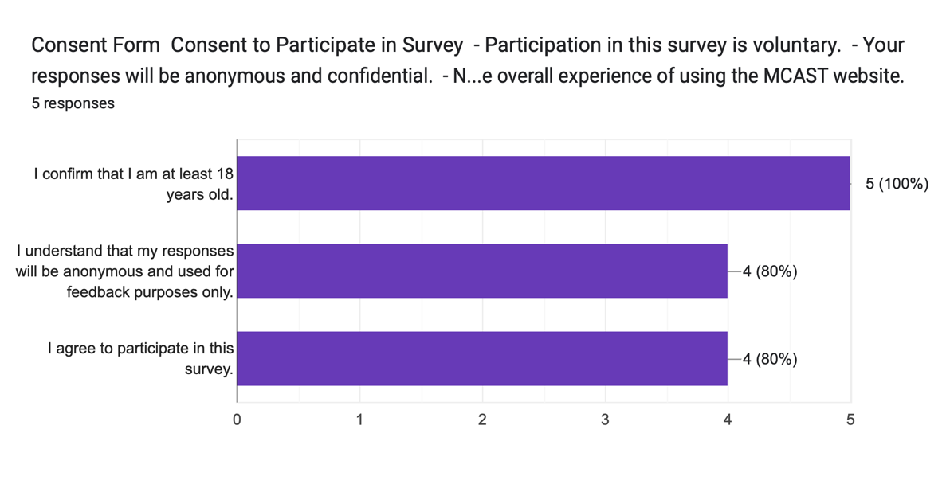The Responses:

### The

### User Persona



The CV that I have created of the user persona of a girl who is in the fashion industry as interested in finding a course in fashion design. Brittney is a 25 year old women eager to learn more about fashion and is a student in MCAST Mosta, she has finished the advance diploma and soon will be going into bachelor’s with this said she would like to check the curriculum of next year’s subjects but is having hard time to access it as the website is not user friendly and is difficult to access this.

### Design Plan

* My 5 webpages are: **Home**,**Contact Us**,**Courses / Programs**,**Admissions** and **Student Portal.**

### 

### My Lo-Fi wireframes



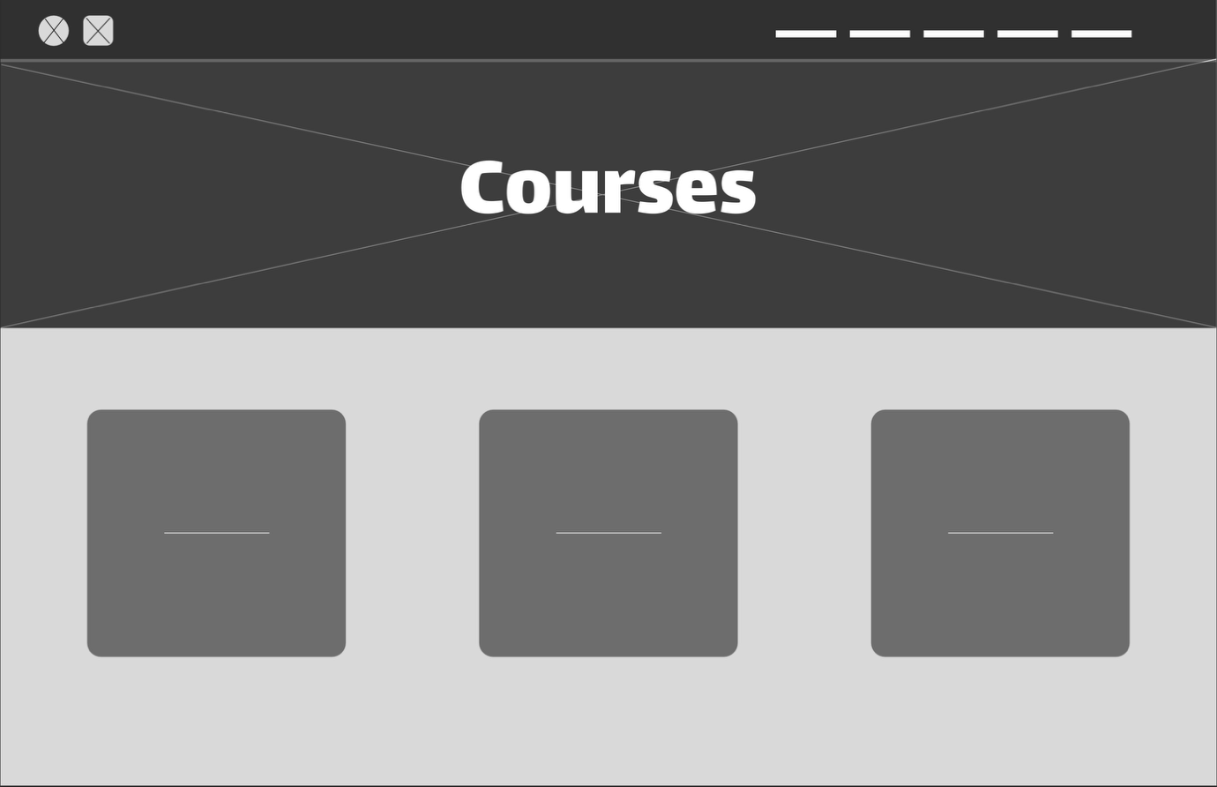

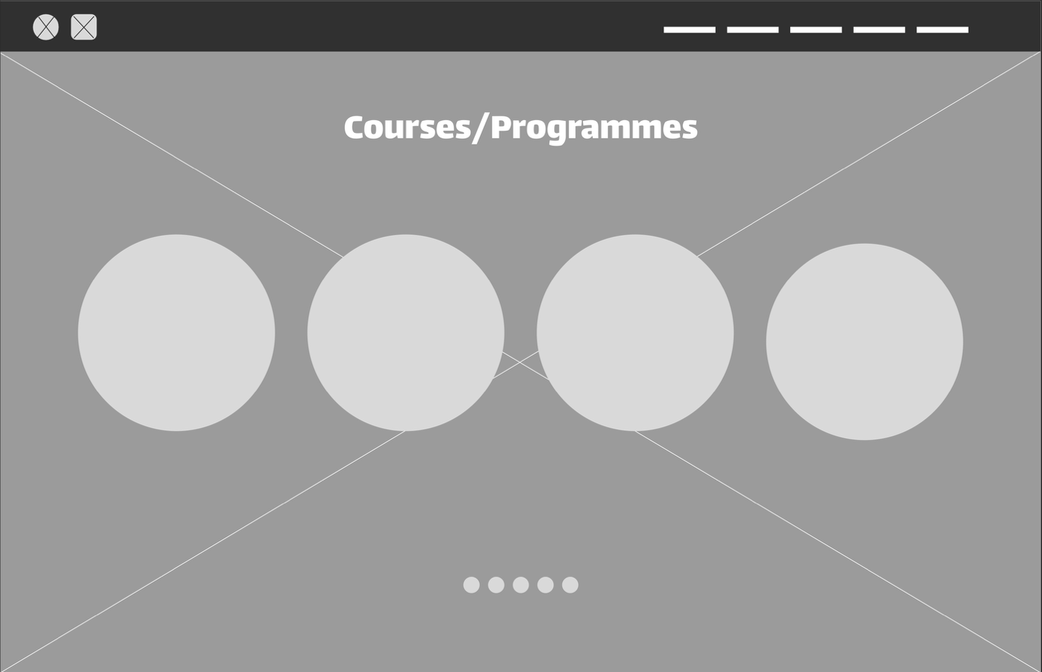

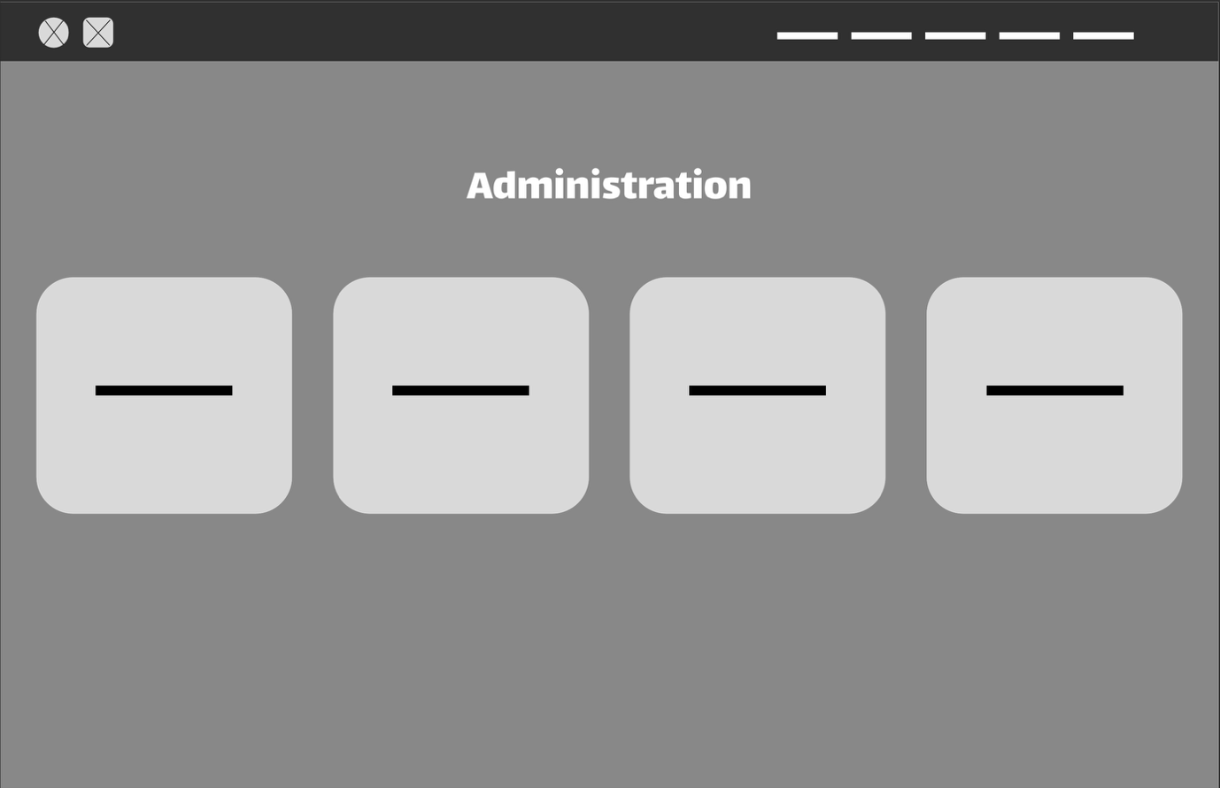

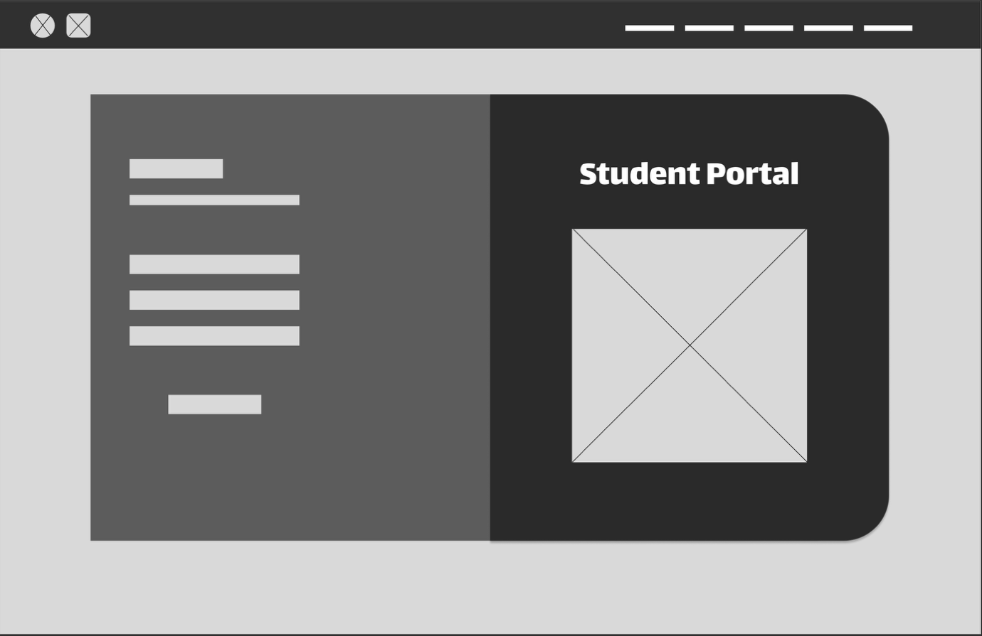

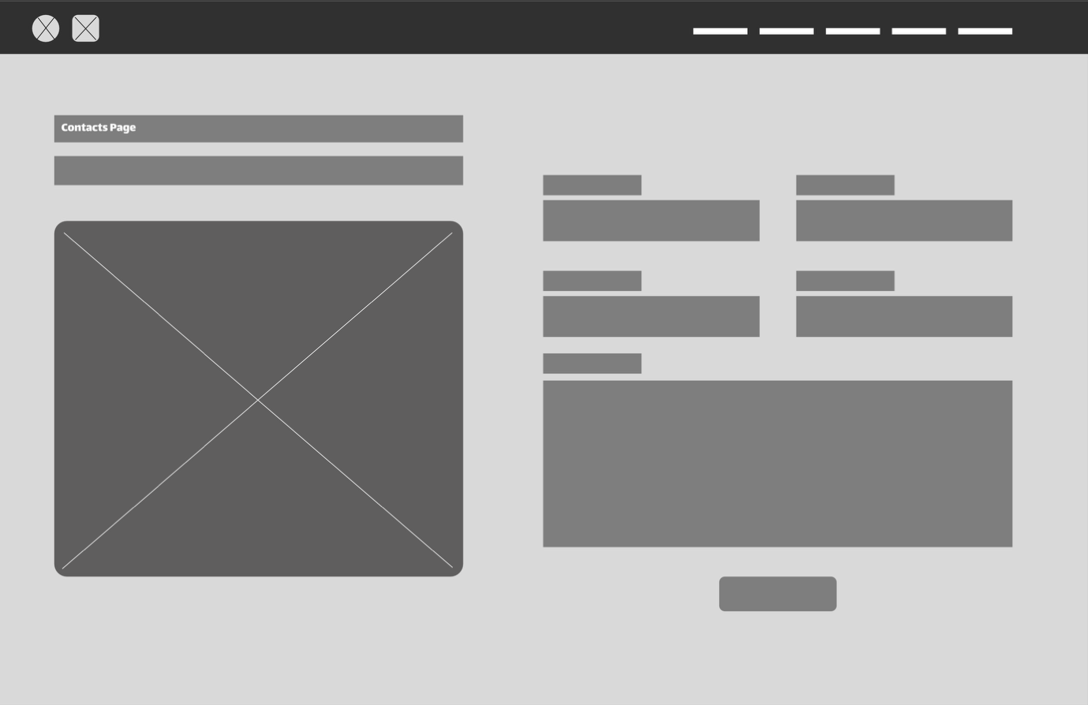

### My Style Guide:

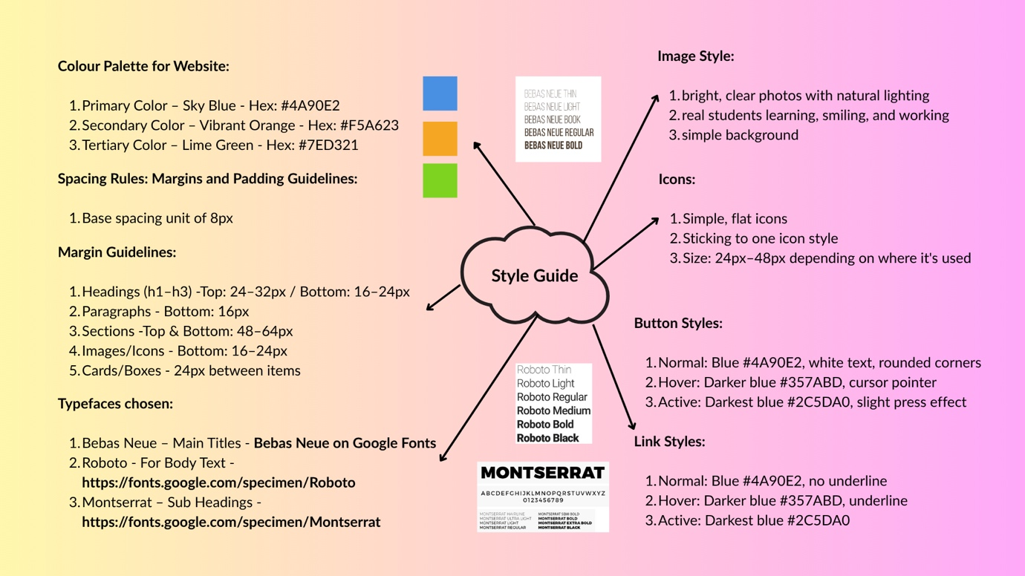

### Hi – Fi Wireframe

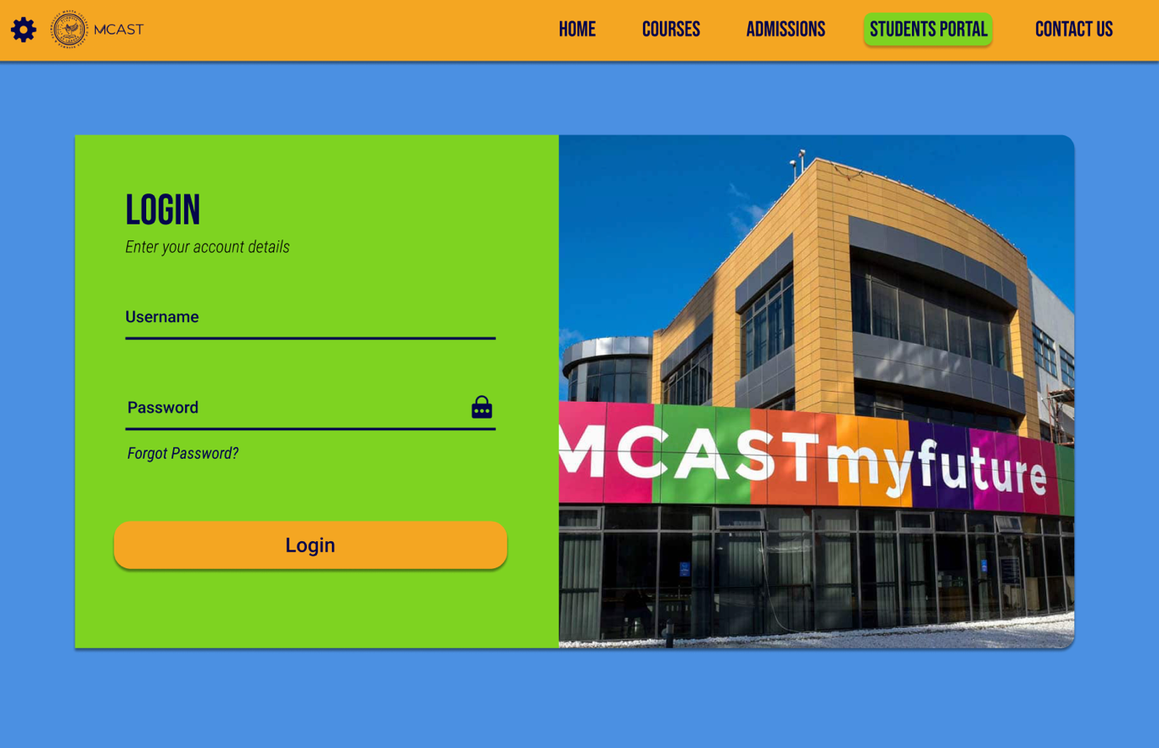

Evaluation

In 300 - 400 words, evaluate your redesign against your User Persona:

• What works well? Identify strengths in your redesign.

• What needs improvement? Highlight any weaknesses.

• Feedback: Support both points with at least 2 quotes from your survey respondents.

Task 4: Evaluation

The user persona created is based on a student that could have similar issues to what she has to use the website. When it came to redesigning it one of the things that worked well when changing it was the colour palette, even though the original website has a very simple style which gives more a plain style I wanted to risk bright fun colours, and these gives a nice vibe to the website. Something that also worked well is that you easily find something without any problems or the need to use any search bars. I wanted to leave the website simple so a user would be able to go throughout without seeing getting overwhelmed to see a lot of information at once. Other things that I saw that works well in my redesign are the font choice and colour as it is readable, the little elements added such as hover effect and the images used overall it is aesthetically pleasing to the user and can be used without any confusion. Something that I would say it would need improvement is in making the website work more as without JavaScript I was limited to what I can do. Apart from this I don’t see that I need to improve in a lot of things as I dedicated time to make the website specifically to look like this so overall I have hit the goal I wanted, one thing that maybe I need to improve in functionality is in the second webpage when you press example on the Full Time Course and close the pop up again it takes you back to the top, this was one thing that I could not manage to fix and I would defiantly need to improve as it would be annoying to take you back to the top every time. Two things I got from feedback where ‘’ The menu is too cluttered and gets confusing sometimes’’ and ‘’ make it more UI friendly, make it more easy to navigate through it and make it more aesthetically appealing’’ these where some comments that I had in the form survey I had done. When comparing these comments to my work that I have done in my website I think I have done a good job as the menu bar was left clean and simple and navigatio wise nothing was clusstered, apart from that as stated before aesthetically wise the colours went well and made it fun for the user.